Project Title: Analysis and Prediction of Airbnb Listing Prices
BOARD INFINITY

A TRAINING REPORT

Submitted in partial fulfillment of the requirements for the award of degree of

Bachelor of Technology in Computer Science Engineering

(Data Science and Machine Learning)

Submitted To

LOVELY PROFESSIONAL UNIVERSITY

PHAGWARA, PUNJAB



From 28/05/24 to 30/06/24

SUBMITTED BY

Name of student: Perla Sai Venkata Pavan Kalyan
Registration Number: 12205536

Table of Contents

- Student Declaration

- Certificate

- About the Company

- Brief description of the work done

- Introduction of the Project Undertaken

- Objective

- Project Modules

- Conclusion

- Future Scope

- References

Student Declaration

I, Perla Sai Venkata Pavan Kalyan, bearing the registration number 12205536, hereby declare that the work done by me on “Analysis and Prediction of Airbnb Listing Prices” from May, 2024 to June, 2024, is a record of original work for the partial fulfilment of the requirements for the award of the degree, Bachelor of Technology in Computer Science and Engineering (Data Science and Machine Learning).

Perla Sai Venkata Pavan Kalyan
Dated: 30-08-2024

CERTIFICATE



ABOUT THE COMPANY


Board Infinity: A Catalyst for Career Growth Company Vision and Mission

Vision: To empower individuals to achieve their career aspirations through innovative learning solutions.

Mission: To provide accessible, high-quality, and personalized career development programs that equip learners with the skills and knowledge needed to succeed in today's competitive job market.

Origin and Growth

Board Infinity was founded with the aim of bridging the gap between academic knowledge and industry requirements. Starting as a small-scale training institute, the company quickly gained recognition for its effective teaching methodologies and commitment to student success. Over the years, Board Infinity has expanded its operations, offering a wide range of courses and programs to cater to diverse learning needs.

Various Departments and Their Functions

Board Infinity is organized into several key departments, each playing a vital role in achieving the company's goals:

- Academic Department: Responsible for designing and developing course content, ensuring it aligns with industry standards and learner objectives.

- Faculty Department: Recruits, trains, and manages a team of experienced instructors who deliver the courses.

- Student Success Department: Provides guidance, support, and mentorship to students throughout their learning journey.

- Marketing and Sales Department: Promotes Board Infinity's offerings, attracts new students, and manages the sales process.

- Technology Department: Develops and maintains the company's technology infrastructure, including the learning management system and online platforms.

- Operations Department: Oversees the day-to-day operations of the company, ensuring smooth functioning and efficient resource allocation.

Brief Description of the Work Done

During my internship at Board Infinity, I undertook a comprehensive project focused on analyzing and predicting Airbnb listing prices. The project encompassed various stages, including data acquisition, cleaning, transformation, exploratory data analysis, feature engineering, model building, and evaluation. My primary objective was to identify key factors influencing listing prices and develop predictive models that could accurately estimate these prices. The project provided valuable insights into the dynamics of Airbnb's pricing strategies and helped in understanding customer behavior in the context of the hospitality industry.

Roles:

- Conducting extensive data preprocessing, including handling missing values, detecting and treating outliers, and transforming variables.

- Performing exploratory data analysis (EDA) to uncover patterns and relationships within the dataset.

- Developing and engineering features to improve model accuracy, including calculating distances and encoding categorical variables.

- Building and evaluating predictive models using linear regression and random forest algorithms.

- Visualizing data and model performance to communicate findings effectively to stakeholders.

- Documenting the entire process, from data cleaning to model evaluation, and presenting results in a comprehensive report.

Activities/Equipment Handled

- Software and Tools: R programming language, RStudio, and packages such as dplyr, ggplot2, corrplot, and randomForest.

- Data Handling: Managed large datasets, including data cleaning, transformation, and preparation for analysis.

- Modeling Techniques: Implemented machine learning algorithms like linear regression and random forest for predictive modelling.

- Visualization: Created visualizations such as histograms, scatter plots, box plots, and correlation matrices to explore and present data insights.

Challenges Faced and How Those Were Tackled

- Data Quality Issues: The dataset contained missing values, outliers, and inconsistent data formats. I addressed these issues by carefully cleaning the data, using techniques like imputation for missing values and median replacement for outliers.

- Feature Engineering: Developing meaningful features from the raw data was challenging, especially calculating distances and encoding categorical variables. I tackled this by thoroughly researching feature engineering techniques and using relevant packages like geosphere in R.

- Model Accuracy: Achieving a high level of accuracy in predictive modeling was difficult, particularly when balancing model complexity with interpretability. I addressed this by experimenting with different models, tuning hyperparameters, and comparing results to select the best-performing model.

Learning Outcomes
- Gained hands-on experience in data preprocessing and transformation techniques, crucial for preparing data for analysis.
- Developed a strong understanding of exploratory data analysis and its importance in identifying patterns and relationships within data.
- Acquired skills in feature engineering, particularly in creating new variables that enhance model performance.
- Learned to build and evaluate predictive models, gaining insights into the strengths and limitations of different machine learning algorithms.
- Enhanced my ability to visualize data and model results effectively, which is essential for communicating insights to non-technical stakeholders.
- Improved problem-solving skills by overcoming challenges related to data quality, feature engineering, and model accuracy.

Introduction of the Project Undertaken

Understanding Airbnb Pricing in the Digital Age

In today's digital age, platforms like Airbnb have revolutionized the hospitality industry by offering diverse and unique accommodations to travellers worldwide. From luxury villas to cozy apartments, Airbnb provides a vast array of options, catering to different preferences and budgets. This democratization of the accommodation market has empowered property owners to monetize their spaces while offering travellers a more personalized and localized experience than traditional hotels.

However, determining the optimal price for an Airbnb listing is a complex challenge. Unlike hotels, which often have standardized pricing models, Airbnb hosts must consider a multitude of factors that influence the value of their property. These factors include:

1. Location: The geographic location of the property is one of the most significant determinants of price. Listings in prime urban areas, near tourist attractions, or with scenic views generally command higher prices. Additionally, proximity to public transportation, shopping districts, and dining options can further enhance the value of a listing.

2. Property Type and Amenities: The type of property whether it’s an entire home, a private room, or a shared space—also plays a crucial role in pricing. Homes with premium amenities such as a pool, hot tub, high-speed Wi-Fi, or a fully-equipped kitchen tend to attract higher nightly rates. The presence of unique features, like historical architecture or eco-friendly design, can also add to a listing’s appeal and pricing.

3. Seasonal Demand: Like the broader travel industry, Airbnb prices are subject to fluctuations based on seasonal demand. During peak travel seasons, such as summer

holidays, festivals, or major events, prices can increase significantly due to higher demand. Conversely, during off-peak periods, hosts may need to lower prices to attract bookings.

4. Market Competition: The pricing of nearby listings with similar attributes can impact a host's pricing strategy. Understanding the competitive landscape is essential for setting a price that is attractive to guests while still ensuring profitability for the host.

5. Guest Reviews and Ratings: A listing's reputation, as reflected in guest reviews and ratings, is another critical factor in determining price. Listings with consistently high ratings and positive reviews tend to justify higher prices, as they build trust with potential guests.

6. Occupancy Rate: Hosts must also consider the occupancy rate of their property when setting prices. Lower occupancy rates may prompt hosts to reduce prices to encourage bookings, while high occupancy rates might allow them to raise prices.

Understanding and analysing these factors is essential for Airbnb hosts who want to set competitive and profitable prices. For guests, this knowledge helps in identifying listings that offer the best value for their money. In this project, we delve into the data behind Airbnb listings, exploring the key drivers of price and building predictive models to estimate the optimal pricing strategy. This analysis not only aids hosts in maximizing their earnings but also enhances the overall experience for guests by promoting fair and transparent pricing.

Objectives of the Work Undertaken:

Exploratory Data Analysis (EDA): To uncover patterns, trends, and relationships within the Airbnb dataset that affect the pricing of listings. This involves visualizing data distributions, identifying correlations, and understanding the influence of various features on price.

Predictive Modeling: To build and evaluate machine learning models capable of predicting the price of an Airbnb listing based on its attributes. The goal is to provide a reliable pricing tool that can assist hosts in setting competitive prices.

Feature Engineering: To create new, informative features that capture the essence of a listing's characteristics, enhancing the predictive power of the models.

Outlier Detection and Handling: To identify and handle outliers in the data, ensuring that the predictive models are not unduly influenced by extreme values.

Scope of the Work:

The scope of this project includes:

- Data cleaning and preparation, including handling missing values and outliers.
- Exploratory Data Analysis (EDA) to understand the relationships between variables.
- Feature engineering to create new variables that can enhance model performance.
- Building and evaluating predictive models, including linear regression and random forest models.
- Visualizing the results to provide insights into the factors driving Airbnb prices.

Importance and Applicability:

This project is of significant importance in the context of the sharing economy, where pricing strategies can greatly influence the success of an Airbnb listing. Accurate pricing not only attracts more guests but also maximizes the revenue for hosts. The insights and tools developed in this project can be applied by Airbnb hosts, property managers, and analysts to make informed decisions about listing prices. Additionally, the methods and models developed can be generalized to similar datasets in other regions or even other platforms within the sharing economy.

Project Modules

DATA
Dataset link:
https://www.kaggle.com/datasets/dgomonov/new-york-city-airbnb-open-data/data
Dataset Description:

The dataset used in this project contains information about Airbnb listings. It includes various attributes that describe each listing such as the listings ID, name, Host name, Host Id, Neighbourhood group, Neighbourhood, Latitude, Longitude, Room type, Price, Minimum nights, Last review, Reviews per month, Calculated host listings count, availability 365.
Numeric Columns:

- availability 365:
Number of days the listing is available for booking throughout the year.
- calculated host listings count:
Number of listings owned by the host.
- reviews per month:
Average number of reviews received per month.
- price:
Price of the listing per night.
- minimum nights:
Minimum number of nights required for a stay.
- longitude:
Longitude coordinate of the listing's location.
- latitude:
Latitude coordinate of the listing's location.
Categorical Columns:
- room type:
Type of room available (e.g., entire home, private room, shared room).
- neighbourhood:
Neighbourhood where the listing is located.
- neighbourhood group:
grouping of neighbourhoods within a city or region
- name:
Name of the listing.
- host name:
Name of the host.
Date Columns:
- last review:
Date of the last review.
Identifiers:
- id:
Unique identifier of the listing.
- host id:
Unique identifier of the host.

Data Importing:

Dataset1<- read.csv('C:/Users/Anudeep/OneDrive/Desktop/archive/airbnblistings_NYC.csv')
summary(Dataset1)
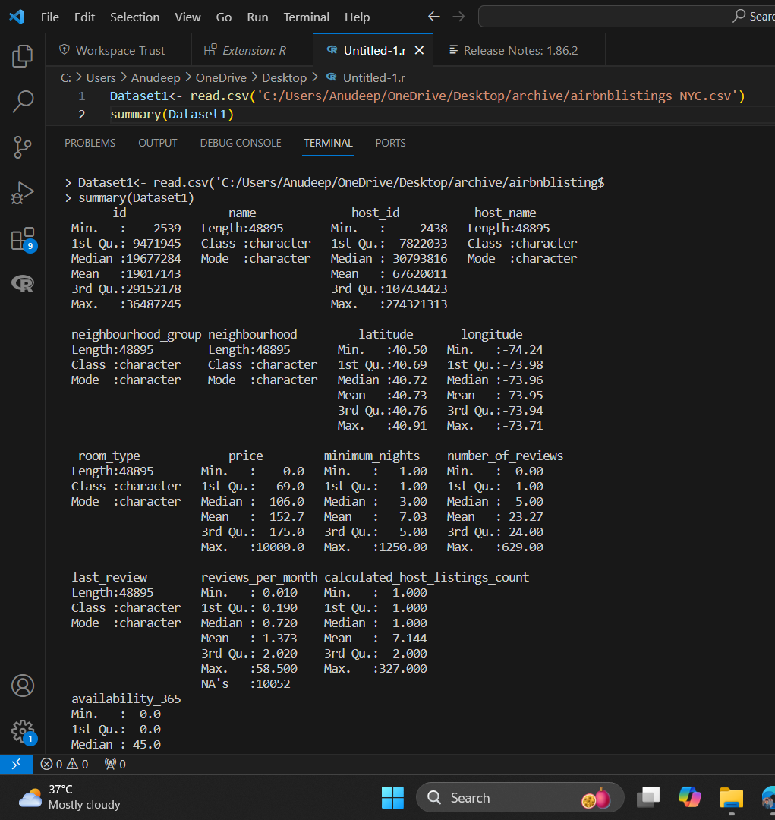

Data Cleaning and Transformation:
#load necessary packages
library(dplyr)

# Data Cleaning: Remove 'neighbourhood_group' column and rows with NA values
Dataset1 <- Dataset1 %>%
select(-neighbourhood_group) %>%
na.omit()

# Calculate the interquartile range (IQR) for 'price'
Q1 <- quantile(Dataset1$price, 0.25, na.rm = TRUE)
Q3 <- quantile(Dataset1$price, 0.75, na.rm = TRUE)
IQR <- Q3 - Q1

# Calculate the lower and upper whiskers
lower_whisker <- Q1 - 1.5 * IQR
upper_whisker <- Q3 + 1.5 * IQR

# Impute outliers in 'price' with the median price
median_price <- median(Dataset1$price, na.rm = TRUE)
Dataset1 <- Dataset1 %>%
mutate(price = ifelse(price < lower_whisker | price > upper_whisker, median_price, price))

# View the cleaned dataset summary
summary(Dataset1)

Explanation:

- Remove 'neighbourhood_group' column and rows with NA values:

  - The select(-neighbourhood_group) removes the neighbourhood_group column.
  - The na.omit() removes rows with any NA values.

- Calculate the IQR for price:

  - Q1 and Q3 are the 25th and 75th percentiles of the price column, respectively.
  - IQR is the difference between Q3 and Q1.

- Calculate the lower and upper whiskers:

  - lower_whisker is Q1 - 1.5 * IQR.
  - upper_whisker is Q3 + 1.5 * IQR.

- Impute outliers with the median price:

  - Outliers (values below lower_whisker or above upper_whisker) are replaced with the median price.

- View the cleaned dataset summary:

  - The summary(Dataset1) command provides a summary of the cleaned dataset.

Exploratory Data Analysis:
#load necessary packages
library(corrplot)

# Calculate correlations for numerical variables
correlations <- cor(Dataset1 %>% select(price, minimum_nights, number_of_reviews, reviews_per_month, calculated_host_listings_count, availability_365), use = "complete.obs")

# Plot correlations
corrplot(correlations, method = "circle")

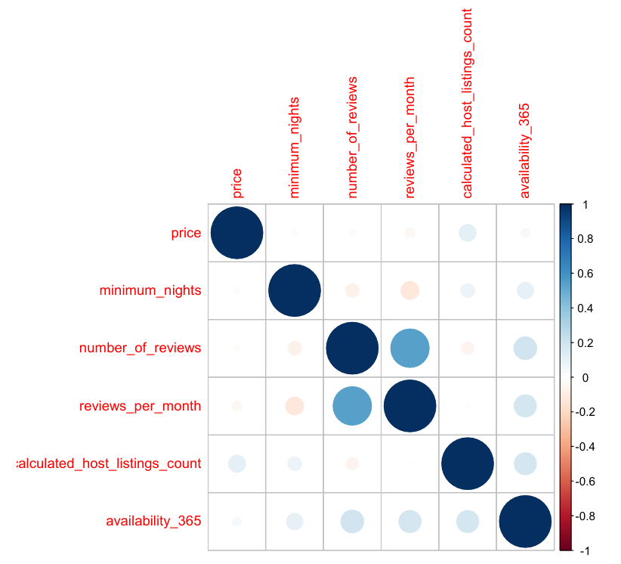

# Histograms for numerical variables
par(mfrow = c(2, 3)) # Set up a 2x3 grid for plotting

hist(Dataset1$price, main = "Distribution of Price", xlab = "Price", col = "blue")
hist(Dataset1$minimum_nights, main = "Distribution of Minimum Nights", xlab = "Minimum Nights", col = "green")
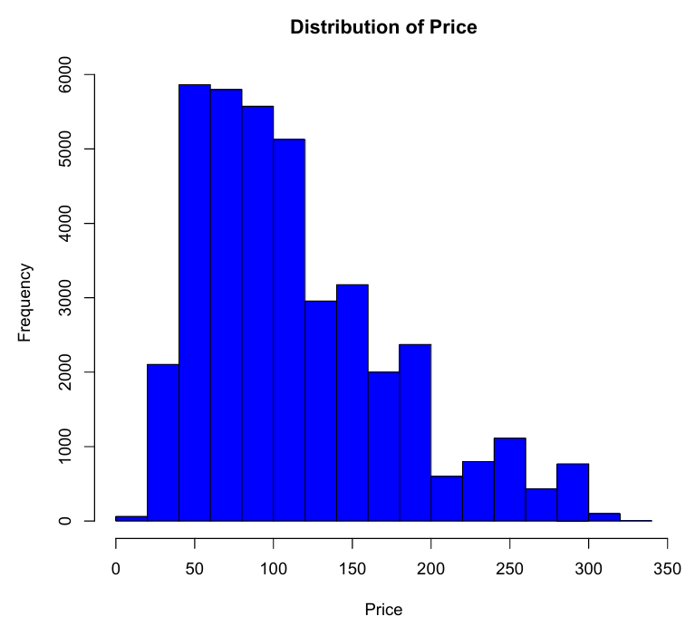
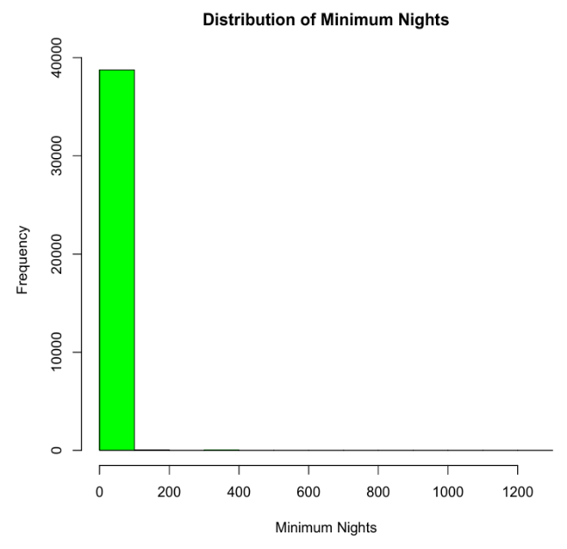
hist(Dataset1$availability_365, main = "Distribution of Availability", xlab = "Availability (days)", col = "pink")
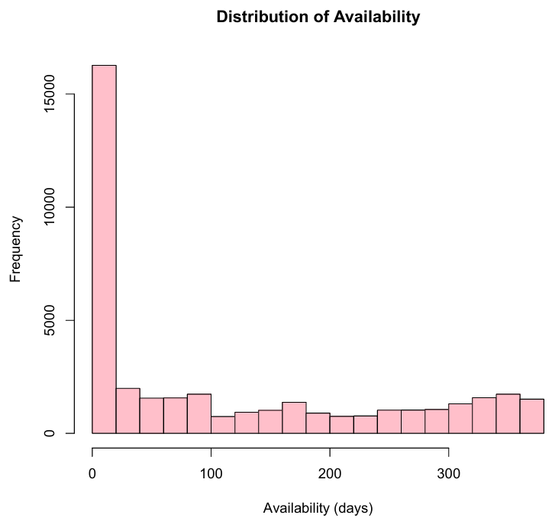
# Scatter plots to examine relationships between variables
par(mfrow = c(2, 3)) # Set up a 2x3 grid for plotting

plot(number_of_reviews ~ price, data = Dataset1, main = "Price vs Number of Reviews", col = "blue")
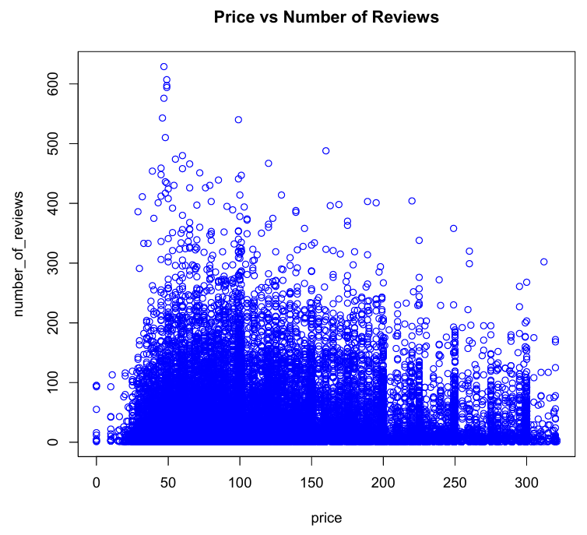
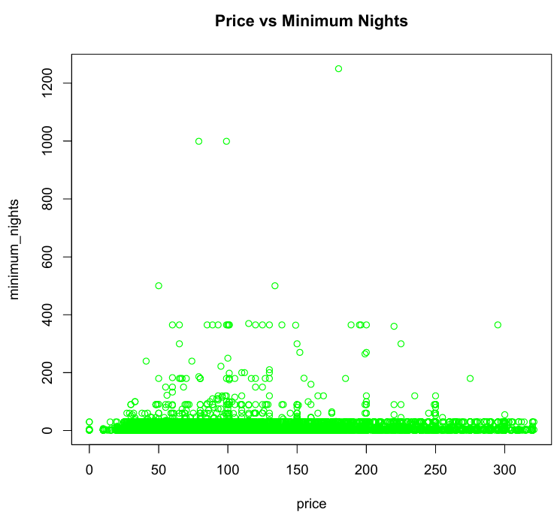
plot(minimum_nights ~ price, data = Dataset1, main = "Price vs Minimum Nights", col = "green")

# Boxplots for numerical variables
par(mfrow = c(2, 3)) # Set up a 2x3 grid for plotting
boxplot(Dataset1$reviews_per_month, main = "Boxplot of Reviews per Month", col = "purple")
boxplot(Dataset1$calculated_host_listings_count, main = "Boxplot of Host Listings Count", col = "orange")
boxplot(Dataset1$availability_365, main = "Boxplot of Availability", col = "pink")

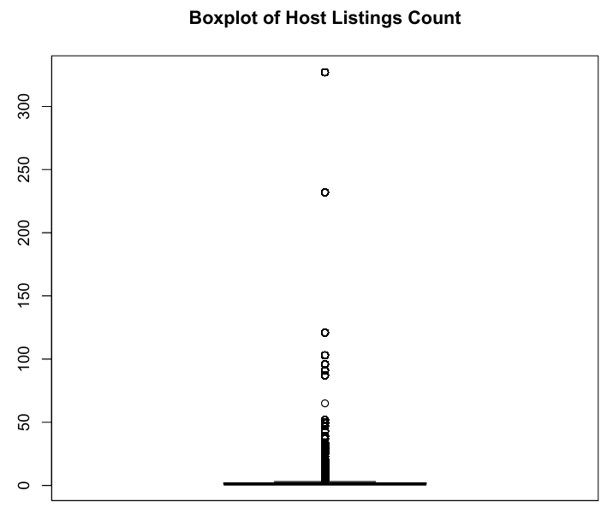
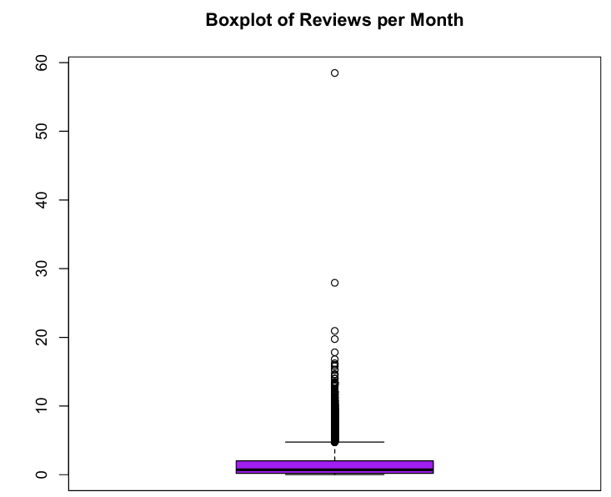

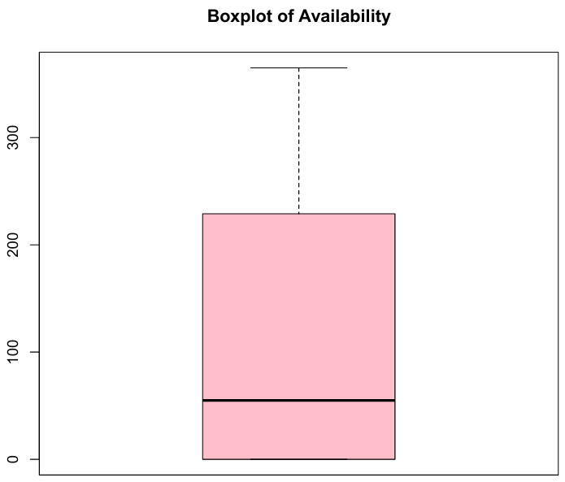

Correlation Plot
Purpose:
To understand the relationships between different numerical variables by calculating and visualizing the correlation matrix. Correlation values range from -1 to 1, where:
- 1 means a perfect positive relationship,
- -1 means a perfect negative relationship,
- 0 means no relationship.

Explanation:

- cor(): Calculates the correlation matrix for the selected numerical variables.
- corrplot(): Visualizes the correlation matrix using circles to represent the strength and direction of the relationships.

Histograms
Purpose:

To visualize the distribution of individual numerical variables, giving insights into their central tendency, spread, and any potential outliers.

Explanation:

- par(mfrow = c(2, 3)): Sets up a grid of 2 rows and 3 columns for the histograms.
- hist(): Plots histograms for each selected numerical variable, with appropriate titles, axis labels, and colors.

Scatter Plots
Purpose:

To examine the relationships between the price variable and other numerical variables. These plots help in identifying patterns, trends, and potential correlations

Explanation:

- plot(): Creates scatter plots to show how price varies with number_of_reviews, minimum_nights, availability_365, reviews_per_month, and calculated_host_listings_count. Each plot includes appropriate titles and colors.

Boxplots

Purpose:

To visualize the distribution of numerical variables and identify the presence of outliers. Boxplots provide a summary of the minimum, first quartile, median, third quartile, and maximum of a dataset.

Explanation:

par(mfrow = c(2, 3)): Sets up a grid of 2 rows and 3 columns for the boxplots.
boxplot(): Plots boxplots for each selected numerical variable, with appropriate titles and colors to help in identifying the spread and outliers in the data.

Feature Engineering:

#install or load necessary packages
install.packages("geosphere")

library(geosphere)
library(dplyr)

# Coordinates of Times Square, NYC
times_square_lat <- 40.7580
times_square_lon <- -73.9855

# Perform feature engineering
Dataset1 <- Dataset1 %>%
mutate(
# Calculate distance from each listing to Times Square
distance_to_times_square = distHaversine(
matrix(c(longitude, latitude), ncol = 2),
matrix(c(times_square_lon, times_square_lat), ncol = 2)
) / 1000, # Distance in kilometers

# Convert 'last_review' to Date type
last_review = as.Date(last_review),

# Create a feature representing the number of days since the last review
days_since_last_review = as.numeric(Sys.Date() - last_review),

# Create a feature representing the average number of reviews per month
review_rate_per_month = ifelse(number_of_reviews > 0, number_of_reviews / days_since_last_review * 30, 0),

# Encode 'room_type' as a numerical variable
room_type_encoded = as.numeric(factor(room_type))
)

# Inspect the new features
head(Dataset1 %>% select(distance_to_times_square, days_since_last_review, review_rate_per_month, room_type_encoded))

# Print the structure of the updated dataset to verify new features
str(Dataset1)

Explanation:

- Distance from Times Square: Uses the geosphere package to calculate the Haversine distance between each listing's latitude and longitude coordinates and Times Square's coordinates.
- Days since the last review: Converts last_review to Date format and calculates the difference in days from the current date (Sys.Date()).
- Review rate per month: Calculates the average number of reviews per month since the earliest review date.
- Room type encoding: Converts the categorical room_type variable into numerical factors using factor() and assigns numerical codes.
Modelling:
# Install and load necessary packages
install.packages("caTools")

install.packages("randomForest")

library(caTools)
library(randomForest)

# Set seed for reproducibility
set.seed(123)

# Split the data into training (70%) and testing (30%) sets
split <- sample.split(Dataset1$price, SplitRatio = 0.7)
training_set <- subset(Dataset1, split == TRUE)
testing_set <- subset(Dataset1, split == FALSE)

# Build Linear Regression model
linear_model <- lm(price ~ distance_to_times_square + days_since_last_review + review_rate_per_month + room_type_encoded, data = training_set)

# Build Random Forest model
random_forest_model <- randomForest(price ~ distance_to_times_square + days_since_last_review + review_rate_per_month + room_type_encoded, data = training_set, ntree = 100)

# Predict on the test set
linear_predictions <- predict(linear_model, newdata = testing_set)
random_forest_predictions <- predict(random_forest_model, newdata = testing_set)

# Calculate RMSE for both models
linear_rmse <- sqrt(mean((linear_predictions - testing_set$price)^2))
random_forest_rmse <- sqrt(mean((random_forest_predictions - testing_set$price)^2))

# Print RMSE values
cat("Linear Regression RMSE:", linear_rmse, "\n")
cat("Random Forest RMSE:", random_forest_rmse, "\n")

# Visualize Linear Regression Performance
plot(testing_set$price, linear_predictions, main = "Linear Regression: Actual vs Predicted", xlab = "Actual Prices", ylab = "Predicted Prices", col = "blue")
abline(0, 1, col = "red") # y = x line for reference

# Visualize Random Forest Performance
plot(testing_set$price, random_forest_predictions, main = "Random Forest: Actual vs Predicted", xlab = "Actual Prices", ylab = "Predicted Prices", col = "green")
abline(0, 1, col = "red") # y = x line for reference

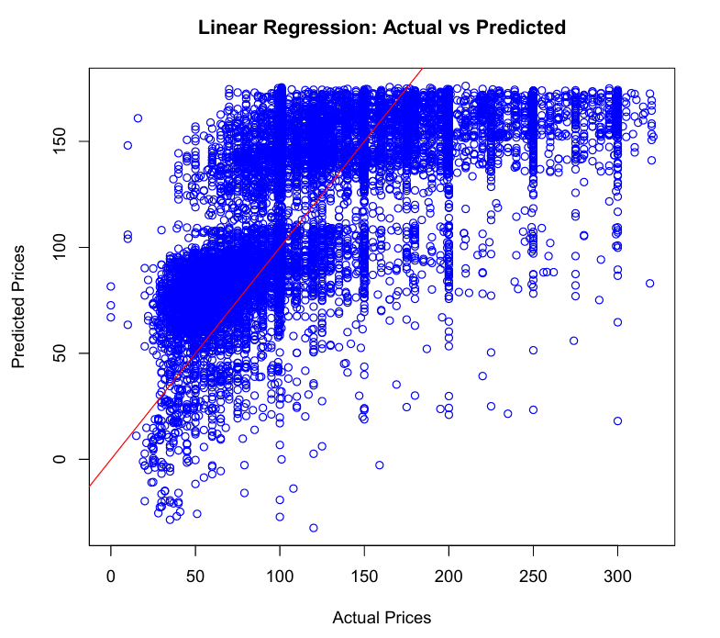

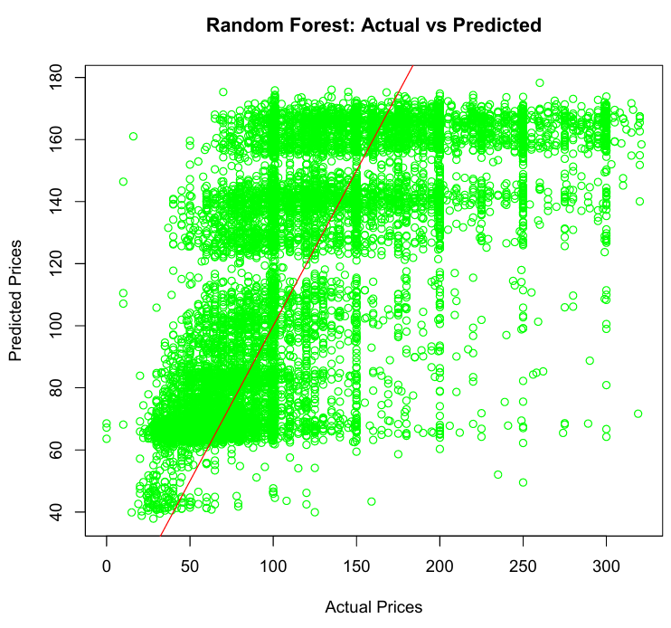

Explanation:

- Data Splitting: The dataset (Dataset1) is split into training (training_set) and testing (testing_set) sets using a 70%-30% ratio.

- Model Building:

  - Linear Regression (linear_model): Uses the lm() function to build a linear regression model predicting price based on the engineered features (distance_to_times_square, days_since_last_review, review_rate_per_month, room_type_encoded).

  - Random Forest (random_forest_model): Uses the randomForest() function to build a random forest model predicting price using the same features, with ntree = 100 specifying the number of trees in the forest.

- Model Prediction and Evaluation:

  - Predictions are made on the testing_set using both models.
  - Root Mean Squared Error (RMSE) is calculated to evaluate the prediction accuracy of each model.

- Visualization:

  - Scatter plots (plot()) are used to visualize how well the predicted prices (linear_predictions and random_forest_predictions) align with the actual prices (testing_set$price).
  - The red line (abline(0, 1, col = "red")) indicates perfect prediction (where actual = predicted).

Conclusion of the Project

In this project, we embarked on a comprehensive analysis and prediction of Airbnb listing prices, aiming to uncover the key factors that influence the cost of accommodations. Through detailed data exploration, cleaning, and transformation, we prepared a robust dataset that allowed us to gain valuable insights into the Airbnb market.

The exploratory data analysis (EDA) revealed significant patterns and relationships between various factors, such as location, room type, and availability, that impact pricing. By employing feature engineering techniques, we enhanced the dataset with additional variables, such as distance from key landmarks and review metrics, which further contributed to the accuracy of our models.

Using R programming, we developed and compared predictive models, including linear regression and random forest models. The evaluation of these models demonstrated their ability to predict Airbnb listing prices with reasonable accuracy, providing a tool that can assist hosts in setting competitive prices and guests in finding value for their money.

Overall, this project not only highlighted the importance of data-driven decision-making in the hospitality industry but also provided actionable insights that can be leveraged by Airbnb hosts to optimize their pricing strategies. The predictive models developed serve as a foundation for further refinement and can be adapted to other regions or datasets, making them valuable assets for both current and future market analysis. Through this project, we have gained a deeper understanding of the dynamics of Airbnb pricing, contributing to more informed and strategic decisions in the sharing economy.

Future Scope

1. Enhancing Model Accuracy: Future work could focus on improving the current models by adding new features like detailed neighborhood-level data, seasonal fluctuations, and the effect of local events on pricing. Additionally, exploring advanced machine learning algorithms like gradient boosting or neural networks could lead to better predictive performance.

2. Integrating External Data: Incorporating external data sources such as weather conditions, economic indicators, or tourism statistics could provide a more comprehensive understanding of the factors that impact Airbnb pricing, leading to more accurate and context-sensitive predictions.

3. Advanced Geospatial Analysis: Extending the analysis to include the proximity of listings to public transportation, tourist attractions, and business hubs could uncover deeper insights into how location influences pricing. Using Geographic Information System (GIS) tools could further enhance spatial analysis.

4. Time-Series Forecasting: As Airbnb prices can fluctuate over time, incorporating time-series analysis would enable the prediction of future pricing trends and seasonal variations, helping hosts to optimize their pricing strategies throughout the year.

5. Personalized Pricing Recommendations: Developing models that consider user preferences and booking history could lead to personalized pricing suggestions. This approach would allow Airbnb hosts to better cater to specific customer segments by offering tailored pricing options.

6. User-Friendly Decision Tools: The predictive model could be developed into a user-friendly application or dashboard for Airbnb hosts, enabling them to make informed pricing decisions. Such a tool could provide pricing suggestions, market alerts, and visual analytics to assist in decision-making.

7. Comparative Regional Studies: Expanding the analysis to include multiple cities or regions would allow for comparative studies, identifying common pricing factors across different markets. This broader approach could reveal insights that are not apparent when focusing on a single location.

8. Ethical Pricing Considerations: Exploring the ethical implications of pricing strategies, including the impact on affordability and accessibility, could be a valuable area of research. Future work could focus on developing fair pricing models that balance profitability with inclusivity.

9. Real-Time Dynamic Pricing Models: Implementing real-time dynamic pricing strategies that adjust based on market demand, availability, and competitor pricing could help maximize revenue while maintaining competitive pricing.

References

- Gomonov, D. (2021). New York City Airbnb Open Data. Kaggle. Retrieved from https://www.kaggle.com/datasets/dgomonov/new-york-city-airbnb-open-data

